Carbody Structure and Exterior

Introduction

Use

Purpose

Parts List

All figures are assigned to an individual page unless views are required to show a complete listing of equipment.
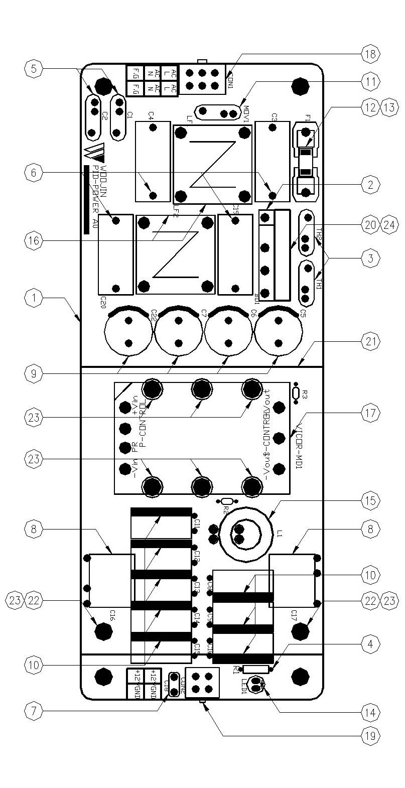

Figure 2.1. PID Power Board
Table 1 - Figure 2.1. pid Power board
FIG No. | PART NUMBERS |  |  | ITEM DESCRIPTION | VENDOR CODE | QTY
 | HRC | VENDOR | DTP
1 |  | PID-POWER A0 |  | . BOARD | HANSAEM | 1
2 |  | D15XB60 |  | . BRIDGE DIODE | SINDENGEN  RECTRON  DIODES | 1
3 |  | DSC150K5SB  DEC5D15  SYP5D15 |  | . THERMISTOR | DSC  DEC  KORYO | 2
4 |  | MRS1/4W3.3KΩFTB  MGR251/4W3.3KΩFTP  SN1/4KT52R3.3KΩF |  | . CARBON FILM RESISTOR | ABCO  RARA  JEIL | 1
5 |  | SDE2E472  HCFZ2G472MAAP10 |  | . CERAMIC CAPACITOR | SAMWHA  NETRONTECH | 2
6 |  | PCX2-335-MJ474  MPX474K31D5 |  | . FILM CAPACITOR | PILKOR  CARLI | 4
7 |  | PCMT-365-85104  EB1J104K |  | . FILM CAPACITOR | PILKOR  SAMHWA | 1
8 |  | MPE630V222K |  | . FILM CAPACITORS | SUNGHO | 2
9 |  | KMG(NHA)400VB47M7.5TP  RD2G476M1631MPA |  | . ELECTROLYTIC CAPACITOR | SAMYOUNG  SAMWHA | 4
10 |  | KXL35VB470M5.0TP  RD1A477M10016PA |  | . ELECTROLYTIC CAPACITOR | SAMYOUNG  SAMWHA | 8
11 |  | INR14D471  SVC471D-14A |  | . VARISTOR | AMOTECH  SAMWHA | 1
12 |  | 0215010.MXP  55T 250V 10A |  | . FUSE | LITTLE FUSE  ORISEL | 1
13 |  | FH51  GF205 |  | . FUSE HOLDER | YEONHO  GEO YOUNG | 1
14 |  | 5GG4SD-01, HIGH  SM5311, Y-GREEN |  | . LED | DAGUANG  AUK | 1
15 |  | 4uH/10A, Φ16, CH166125 |  | . POWER INDUCTOR | TAESUNG  DAEKWANG | 1
16 |  | 2mH/6A, Φ27, ST |  | . LINE FILTER | TAESUNG  DAEKWANG | 2
17 |  | V300B12T150BL |  | . DC/DC CONVERTER | VICOR | 1
18 |  | LWD1140-06P |  | . CONNECTOR | HANLIM | 1
19 |  | LWD1140-04P |  | . CONNECTOR | HANLIM | 1
20 |  | AI, D30 X L20 X H5 |  | . HEAT SINK | EGPOWER | 1
21 |  | AI, D95 X L80 X H16 |  | . HEAT SINK | EGPOWER | 1
22 |  | SUPPORT-BOLT(HEXA) M3X13 |  | . SUPPORT | EGPOWER | 2
23 |  | ROUND, M3XL8mm |  | . BOLT |  | 8
24 |  | ROUND, M3XL10mm |  | . BOLT |  | 1

